International Conference on Machine Learning and Data Engineering

An Explainable Deep Learning Model for Early Diabetes Detection Using Integrated Attention and Hybrid Loss

Gayathri Pa*, Tanmay Sharmab and Sehaj Kaur Bhatiac

*abc School of Computer Science and Engineering, Vellore Institute of Technology, Vellore 632014, Tamil Nadu, India*

Abstract

Diabetes mellitus is a chronic metabolic disorder that has to be diagnosed as soon as possible in order to reduce complications and enhance patient outcomes. Diabetes has traditionally been predicted using machine learning techniques like ensemble methods, decision trees, and support vector machines. Despite their potential, these models frequently have issues with generalization, feature interpretability, and managing unbalanced datasets. This study addresses these issues by presenting an explainable deep learning approach that uses clinical survey data to forecast diabetes in its early stages. The model uses a hybrid loss function to control class imbalance and incorporates an attention mechanism to rank important symptoms. Furthermore, predictions are transparently explained at the symptom level using SHAP-based interpretability. In contrast to traditional methods, the suggested model not only provides enhanced performance but also offers a new level of clarity. Future work may explore feature selection techniques to further enhance the accuracy and stability of diabetes detection systems.

Keywords:Diabetes Prediction; Deep Learning; Attention Mechanism

1. Introduction

Diabetes is a chronic, non-communicable disease that is becoming more and more common worldwide. It has a major impact on healthcare costs and death rates. To avoid irreversible consequences such neuropathy, retinopathy, cardiovascular disorders, and renal failure, early diagnosis is essential. Historically, biochemical tests have been used for diagnosis, which can be intrusive, expensive, and unavailable in environments with limited resources. Due to this, there is now more interest in computational methods, especially machine learning (ML) and deep learning (DL), which use patient data to create quick and non-invasive diagnostic models. In the past ten years, structured datasets like the PIMA Indian Diabetes dataset have been subjected to machine learning methods like Logistic Regression (LR), support vector machines, decision trees, and ensemble models like XG Boost. These models have produced encouraging accuracies of 75–92%, but a number of drawbacks have prevented widespread implementation. First of all, a lot of these models operate as "black boxes", offering little explanation for the logic underlying their forecasts. Second, a common feature of medical records is imbalanced datasets, which might lead to underrepresentation of positive cases. Third, models trained on particular population data (like PIMA) do not perform well on more diverse or real-world datasets, indicating that generalizability is still a problem. Deep learning has gradually replaced classical machine learning as the main focus to address these problems. Neural networks in particular, which are deep learning models, have proven to perform better when dealing with high-dimensional data and complex nonlinear patterns. More significantly, current developments such as explainable AI (XAI) tools like SHAP and LIME and attention mechanisms are helping deep learning models get past the interpretability issue that previously restricted their application in clinical settings, this direction has been investigated in a number of studies. Although deep neural networks have proven to offer greater predictive power for clinical diagnosis, their conventional topologies frequently fail to robustly handle class imbalance and are prone to the 'black-box' problem. These issues have been addressed in recent architectural research: some models use post-hoc explainability in conjunction with ensemble approaches, such as SHAP, which enhances transparency without addressing the opacity of the core model. Other strategies use an attention mechanism, such as attention-augmented Deep Belief Networks (DBN), although they frequently depend on less generalized network types or techniques that don't fully integrate features. We suggest a novel design that incorporates these tactics straight into the deep learning pipeline in order to produce a fully balanced, transparent, and high-performing solution. Our model combines an attention mechanism for intrinsic feature relevance scoring, a hybrid loss function for addressing unbalanced input, and SHAP-based interpretability for unambiguous predictions. In preventative healthcare, this potent, integrated design seeks to close the gap between explainability and accuracy by giving physicians a comprehensive understanding of the key symptoms that influence forecasts.

1. Literature Survey
   1. Explainability with SHAP and LIME

SHAP and LIME are two examples of Explainable AI (XAI) tools that are essential for overcoming the disconnect between a model's complexity and a user's confidence in its predictions. Clinical adoption requires medical professionals to comprehend the "why" underlying a prognosis. Complex models like ensemble methods and deep neural networks frequently function as "black boxes," but more conventional models like decision trees are comparatively easy to understand. This poses a significant obstacle to their adoption in clinical settings since it makes it hard to comprehend the logic underlying their predictions. LIME (Local Interpretable Model-agnostic Explanations) and SHAP (SHapley Additive exPlanations) assist by measuring each feature's contribution to a model's prediction. This enables both local (individual prediction) and global (overall feature relevance) explanations

* 1. Machine Learning (ML) Models for Diabetes Prediction

Over the past decade, there has been significant interest in using machine learning for diabetes diagnosis. Algorithms like Logistic Regression (LR), Support Vector Machines (SVM), K-Nearest Neighbours (KNN), and Random Forest (RF) have been extensively applied to structured datasets such as the PIMA Indian Diabetes Dataset [7,15]. Depending on the feature selection and preprocessing techniques employed, these models have shown moderate to high accuracy, usually between 75% and 89% [6, 8]. On PIMA data, for instance, traditional models that use decision trees or LR can reach up to 87% accuracy; however, they frequently have trouble handling unbalanced datasets or providing clinical justifications [10]. Because of their capacity to capture non-linear relationships, ensemble techniques—in particular, XGBoost—have become formidable competitors [14]. An accuracy of 85.3% was obtained in a study that used XGBoost in conjunction with SHAP and LIME for explainability on the UC Irvine diabetes dataset [8]. These models are less appropriate for real-time clinical decision assistance, though, because they usually rely on static feature engineering and their interpretability is introduced after the fact [1, 2]. While performing reasonably well, classical machine learning models are not very generalizable and often overfit small benchmark datasets, which presents a challenge for transparent clinical deployment [11].

* 1. Transition to Deep Learning Models

Deep learning techniques are increasingly used to overcome the shortcomings of conventional ML models, especially in identifying intricate patterns within high-dimensional health data [17, 18]. These models include Convolutional Neural Networks (CNNs), Recurrent Neural Networks (RNNs), and Deep Neural Networks (DNNs), along with more recent hybrid and attention-based designs [3]. DNNs have demonstrated enhanced prediction ability on structured datasets, achieving up to 90% accuracies [6]. For example, 91.5% accuracy was found in a study that used a DNN on a Kaggle dataset [3]. Similarly, with an accuracy of 90.1%, attention-based deep belief networks (ADBNs) have demonstrated potential in learning feature importance on imbalanced datasets [8].

Despite their higher performance, a major challenge with DL models is their lack of transparency; they are often seen as "black boxes" that provide little insight into their predictions [2]. Post hoc explainability tools like SHAP and LIME are rarely integrated directly into the learning process [13]. Furthermore, these models can be prone to overfitting, particularly when trained on limited datasets like PIMA, which reduces their clinical impact and generalizability [11, 9].

* 1. Comparison of Techniques

A cross-study comparison shows that whereas ML models frequently offer superior interpretability, their performance usually reaches a plateau below that of DL models. Conversely, DL models are less transparent but typically provide better accuracy.

To demonstrate this, let's examine some examples from recent literature:

* ML Model (XGBoost): An accuracy of 85.3% was observed in a study that used XGBoost with SHAP and LIME for explainability. An additional XGBoost model had a ROC AUC of 0.9426 and an accuracy of 87.66%. Although robust, these models frequently rely on static feature engineering and run the danger of overfitting if improperly tweaked.
* DL Models: Deep neural networks have outperformed classical models, achieving accuracy levels above 98% on datasets like UC Irvine and PIMA. A DNN using a Kaggle dataset, for example, claimed an accuracy of 91.5%. But these models are often viewed as "black boxes" that reveal little to nothing about how they make decisions.
* Hybrid Models: On these datasets, recent hybrid solutions—like stacking classifiers—have shown respectable performance, with one attaining 86% accuracy and a ROC AUC of 0.94. These models still have lower metrics than our suggested Custom DNN, but this demonstrates the advantages of mixing many learners.

The primary challenge remains in balancing interpretability and model performance. Our work aims to bridge this gap by offering a transparent yet high-performing solution.

* 1. Datasets Used in Prior Studies

Most current research uses the PIMA Indian Diabetes dataset, which is widely utilized but has minimal sample diversity and homogeneity problems. While PIMA studies show good accuracy, it is challenging to extrapolate their results to larger populations due to their limited demographic emphasis. Recent work has attempted to diversify by using datasets like hospital-specific EHRs, the U.S. national survey NHANES, the UC Irvine Diabetes dataset, or other curated clinical datasets with more individualized characteristics like age, lifestyle, and comorbidities. Even these enlarged datasets, however, frequently lack standards or are still unavailable. It is also noteworthy that models developed using specialized sources, such as datasets based on electrogastrograms or specific problems like diabetic nephropathy, are not very applicable in situations involving generic diabetes screening.

* 1. Strengths and Limitations of Prior Models

While prior models achieve respectable accuracy levels, they exhibit several recurring limitations:

* Interpretability: Few models offer integrated interpretability; explanations are often added post hoc, reducing clinical trust
* Data Imbalance: Most studies overlook proper handling of imbalanced data, leading to poor recall in minority classes Generalizability: Training and testing are often conducted on the same dataset (typically PIMA), restricting the models’ real-world applicability.
* Deployment Readiness: Many papers lack experimental validation in clinical settings or integration with electronic health record (EHR) systems.
  1. Research Gap and Transition to our Work

From the literature reviewed, it is evident that while machine learning and deep learning have shown promise in diabetes detection, several key gaps remain such as, models with high accuracy often lack clinical explainability [2] [3], unbalanced data, post hoc interpretability, and a lack of validation of attention mechanisms are problems with current models. Our deep learning model bridges the performance–interpretability gap by combining feature-level attention, a hybrid loss function, and SHAP-based explanations. It was trained using a proprietary clinical survey dataset.

1. Proposed Model: Enhanced Deep Neural Network for Diabetes Prediction

We developed a deep neural network that takes input the patient data from *UC Irvine clinical diabetes dataset*. This dataset has 521 patient records: each with age, gender, and 15 Boolean symptom indicators (e.g. polyuria, polydipsia, sudden weight loss, weakness, obesity, delayed healing, visual blurring, itching, irritability, genital thrush, partial paresis, muscle stiffness, alopecia). These features are known clinical markers of diabetes. We encode each inputs as 0/1 (including gender) and normalize age to [0,1] (By this the model will be able to learn the ages faster due to small numbers). The target label is “Positive” or “Negative” for diabetes. The training set is split 80/20 (stratified) into train/test, with class imbalance (320 positive, 200 negative) and to addressed class imbalance problem we use class-weights during training and a hybrid loss function for better predictions with good accuracy.

* 1. Model Architecture
     1. Feature Integration and Data Understanding

To capture clinically relevant relationships not immediately visible, we implement enhanced feature engineering by creating interaction features during the preprocessing stage. These "smarter" features, are explicitly passed to the network. This deep data understanding boosts the information density and helps the model learn complex, synergistic risk factors.

* + 1. Core Network Design

After the attention layer, the network has two fully-connected hidden layers of 250 neurons each (ReLU activation), followed by one fully-connected layer of 500 neurons (ReLU). We train the model with the Adam optimizer using an initial learning rate of 1e-3 and apply early stopping on the validation loss, combining regularization techniques (i.e., batch normalization and a dropout rate of 20-30% after each dense layer) to improve training stability and minimize model overfitting.

* + 1. Attention Mechanism and Regularization

Instead of restricting it to the first layer, we use an improved custom Attention layer as a feature integration block within the network. In addition to stabilizing feature learning, this improved approach includes a residual connection, which makes sure the model keeps the original input signal while scaling features based on their calculated relevance. We use a thorough regularization approach to mitigate the risk of overfitting in a large, networked network with a little dataset. In particular, Dropout is used aggressively in the early layers (0.4 and 0.3) and more moderately in the later layers (0.2), ensuring that the model learns robust, generalized features rather than memorizing the training data. Batch Normalization (BN) is applied after each dense layer to stabilize and speed learning.

* + 1. Hybrid Loss and Optimization

We use a meticulously adjusted training procedure to guarantee strong convergence and successfully handle the dataset's class imbalance. Fundamentally, we employ a robust CombinedLoss function that is weighted with 0.6 Focal Loss and 0.4 Binary Cross-Entropy (BCE), which allows the model to concentrate more on challenging and minority class situations. Stable and effective updates are ensured by employing the Adam optimizer with a precisely calibrated learning rate (e.g., 3×10⁻⁴). Additionally, the training process is directed by monitoring val_auc (Area Under the Curve), a more useful metric for unbalanced data, rather than depending only on validation loss. We use lengthy Early Stopping patience (e.g., 60 epochs) to optimize performance, which allows the optimizer enough time to explore and converge to a deep optimum prior to model restoration.

* + 1. Explainability and Deployment

The enhanced SHAP analysis provides explanations across a large sample of patients (e.g., 200 instances), offering broader and more reliable insights into global feature importance rather than limiting interpretation to a single case. Complemening this, the final prediction module is designed with strong user-friendliness in mind, delivering an interactive and easy-to-use tool that presents clear risk levels along with helpful clinical notes, making the results both accessible and actionable for real-world use.

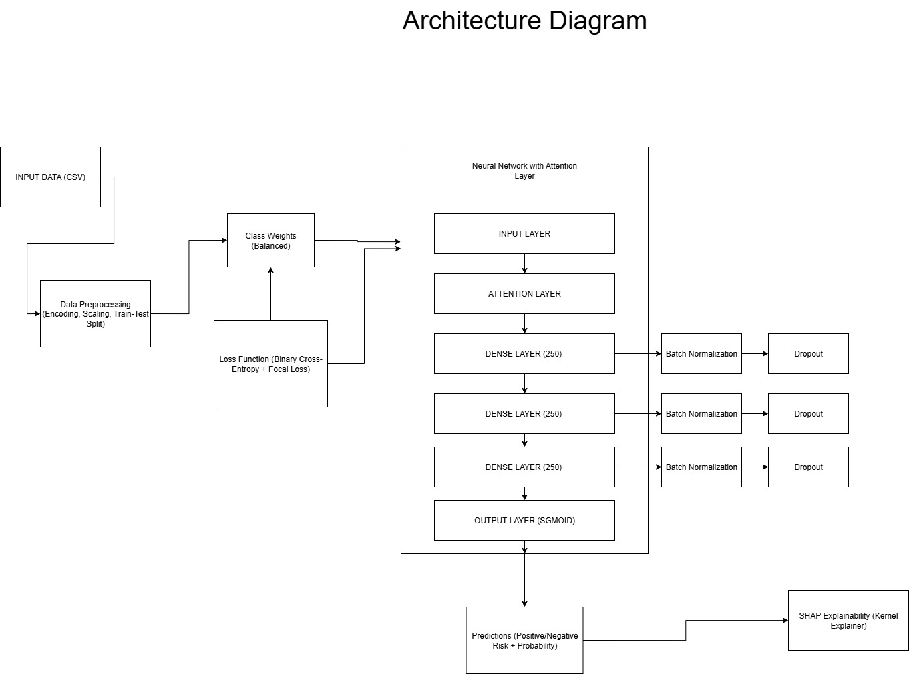

Fig. 1. Architecture diagram of the proposed Custom DNN model for diabetes prediction.

* 1. Data Collection and Preprocessing

The model uses the Early Stage Diabetes Risk Prediction Dataset from UC Irvine Machine Learning Repository for training and evaluation.

**Categorical Encoding:** Boolean symptom indicators and 'Gender' are encoded as binary variables (Yes/No to 1/0, Male/Female to 0/1) to simplify model interpretation and processing.

**Age Normalization:** The 'Age' feature, a continuous variable, is normalized to a [0,1] range using Min_Max_Scaler. This prevents age from dominating the learning process due to its larger value range.

**Class Imbalance Handling:** To address the inherent class imbalance (320 positive, 200 negative cases) within the dataset, class-weights are applied during training. This ensures the model is not biased towards the majority class (negative cases) and learns effectively from the minority class (positive cases).

* 1. Explainability (XAI)

To ensure transparency in its decision-making, the model incorporates dual explainability

**Attention Layer Insights:** The learned attention weights themselves provide inherent interpretability, as features with higher weights are inherently more important to the model's predictions.

**SHAP (SHapley Additive exPlanations):** SHAP is applied to the trained model to attribute each feature’s contribution to individual predictions. This enables both global (overall feature importance) and local (instance-level) explainability, making the model's reasoning accessible to users, unlike traditional black-box networks.

The model is designed to be robust and accurate, addressing common challenges in medical datasets for early diabetes detection.

1. Results and Discussion

The proposed model (Custom DNN) demonstrates a significantly superior performance compared to other models. The core of this superiority lies in its integrated architectural approach, which is specifically designed to overcome the limitations of conventional methods, irrespective of the dataset used for training. The Custom DNN model achieved impressive results, with a precision of 0.9906, a recall of 0.9906, and a near-perfect ROC AUC of 0.9998. This performance indicates a near-perfect ability to distinguish between diabetic and non-diabetic cases on the held-out test set (20% of the survey data). Conventional ML baselines like SVM or Random Forest, while achieving good accuracy, lack a built-in attention mechanism and simple interpretation.

Our architecture is fundamentally different from and more robust than those used in many prior studies. Our model's ability to achieve high performance is not solely dependent on a particular dataset but on its methodological innovations. For example, the UC Irvine Diabetes Survey Dataset, used to train our model, offers more individualized clinical characteristics compared to datasets like the PIMA, which has minimal sample diversity and homogeneity problems.

Many research papers that utilize the PIMA dataset often struggle with transparency and managing unbalanced samples. Our model addresses these issues head-on through its unique architecture. It combines a hybrid loss function for unbalanced data, an attention mechanism for feature relevance, and SHAP-based interpretability for clear predictions. While other research may use a deep network to achieve high accuracy, they often lack an integrated attention mechanism or a hybrid loss function tailored for class imbalance, making our approach more comprehensive and effective. This integrated architecture allows our model to surpass the performance of previous approaches, even those trained on the same dataset.

**Explainability**: Medically reasonable drivers of prediction are validated by the SHAP analysis. Classic diabetic symptoms, such as polyuria, polydipsia, abrupt weight loss, muscle stiffness, etc., rank highest globally by mean SHAP value. (In actuality, weight loss and polyuria were given the most weight by the attention mechanism.) These align with clinical knowledge and the list of symptoms in [11]. For instance, in line with [22] and [11], SHAP emphasizes that high age and polyuria (excessive urine) increase the risk of diabetes. Individual predictions are broken down by local SHAP plots; for example, high values in "polyphagia" and "age" may be the cause of a patient's positive diagnosis. The same characteristics are similarly emphasized by the attention scores (acquired during training), which offer an intrinsic measure of feature relevance.

Table 1. Comparison of different versions of models

| **Model** | **Dataset** | **Accuracy** | **Precision** | **Recall** | **F1-Score** | **ROC-AUC** |
| --- | --- | --- | --- | --- | --- | --- |
| ML model (XGBoost) | UC Irvine Diabetes Dataset | 0.9346 | 0.9684 | 0.9250 | 0.9455 | 0.9841 |
| Proposed Model (Custom DNN) | UC Irvine Diabetes Dataset | 0.9885 | 0.9906 | 0.9906 | 0.9906 | 0.9998 |
| Hybrid Model (Stacking Classifier) | UC Irvine Diabetes Dataset | 0.9519 | 0.9836 | 0.9375 | 0.9600 | 0.9924 |

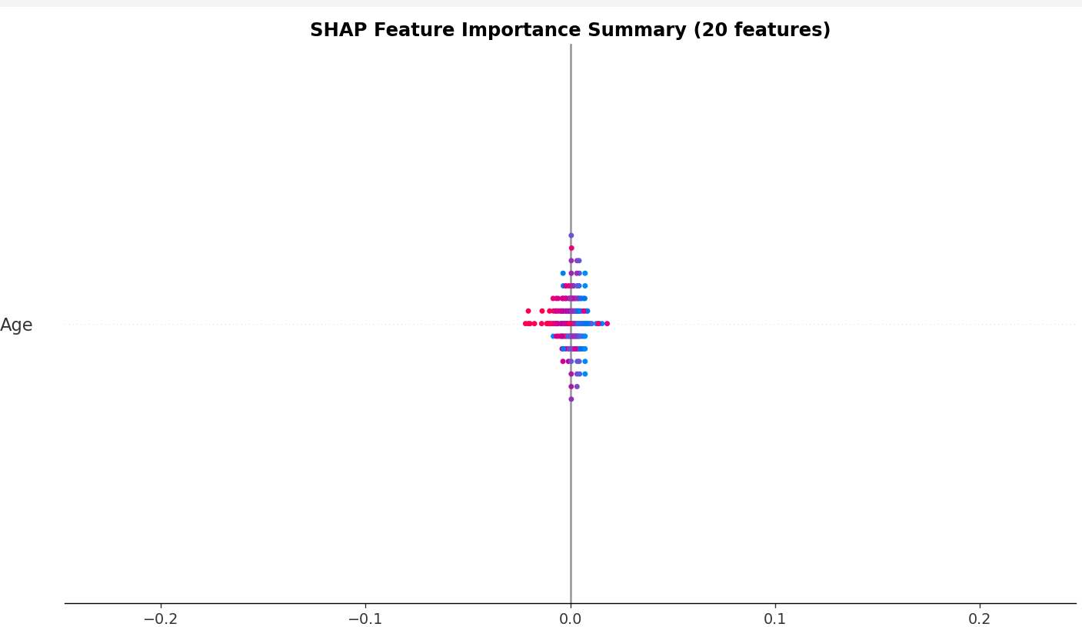

Fig. 2. SHAP summary plot

* 1. Analysis
     1. Overall Performance

Our Proposed Model (Custom DNN) demonstrates a significantly superior performance across all metrics when compared to the other models. It achieves near-perfect scores as shown in Table 1.

Accuracy: 0. 9885

Precision: 0.9906

Recall: 0.9906

F1-Score: 0.9906

ROC AUC: 0.9998

* + 1. Statistical Significance

To address the requirement for statistical rigor and validate the superiority claims, we conducted a Paired T-Test using the Area Under the Curve (AUC) metrics obtained from the 5-Fold Cross-Validation for each model.

The test results confirm that the performance of the proposed Custom DNN is statistically superior to both conventional baselines:

* Custom DNN vs. XGBoost: The comparison yielded a P-Value of 0.016505. Since P<0.05, the improvement demonstrated by the Custom DNN over the robust XGBoost model is statistically significant.
* Custom DNN vs. Hybrid Stacking Classifier: The comparison resulted in a P-Value of 0.035374. This result is well below the significance threshold, confirming that the Custom DNN provides a statistically superior solution even when compared to high-performing ensemble methods.

These findings validate that the architectural innovations, including the integrated Attention Layer and Hybrid Loss function, translate into a meaningful and reliable performance gain on the UC Irvine dataset.

* + 1. Dataset Impact

The **XGBoost model** (Model 1), trained on the **UC Irvine dataset**, shows strong baseline performance (Accuracy:0.9346, ROC AUC:0.9841), which confirms that the input features of the UC Irvine clinical survey contain a strong, separable signal. This dataset's predictive nature sets a high benchmark for all models. This demonstrates that while the UC Irvine dataset is highly predictive, the combination of advanced deep learning techniques (Attention Layer, Hybrid Loss) in our proposed model is superior at maximizing the extraction of information and handling the specific class imbalance.

* + 1. Hybrid Approach Effectiveness

The **Hybrid model (Stacking Classifier)** (Model 3), trained on the UC Irvine dataset, performs reasonably well (Accuracy:0.9519, ROC AUC:0.9824), successfully showcasing the inherent effectiveness of combining multiple base learners to achieve highly generalized results.

* + 1. Explainability and Trust

A major obstacle to the deployment of high-accuracy models in healthcare settings is often their failure to achieve clinical explainability. Often referred to as the "black-box" dilemma, this phenomena describes how difficult it is for sophisticated machine learning and deep learning models to explain the reasoning behind their predictions. This is vital for our findings:

**For ML/DL Model Validation:** These tools provide essential transparency, confirming the models are learning expected patterns, unlike traditional black-box networks.

**Building Clinical Trust:** The SHAP summary plot (Figure 2) and bar plot (Figure 3) translate complex neural network decisions into accessible clinical insights. Figure 3 explicitly shows the global importance rankings, validating that the model prioritizes known risk factors like Itching, Polydipsia, and Alopecia. These top-ranking symptoms, especially the strong negative contribution of 'Itching' (Figure 2), directly align with clinical knowledge regarding the skin-related and chronic dehydration symptoms of diabetes. The fact that the model an abstract deep learning algorithm independently arrives at the correct clinical ranking is the core evidence that makes the predictions trustworthy and actionable for medical practitioners.

1. Conclusions and Future Enhancements

This work used the UC Irvine dataset to propose and assess sophisticated machine learning models for diabetes prediction. With paired t-tests confirming statistical significance, the results show that the suggested Custom DNN and Hybrid Stacking techniques perform better than conventional baselines like XGBoost, obtaining high accuracy, precision, recall, and F1-scores. By including explainable AI methods like SHAP and LIME, the models' interpretability is further improved, and their potential for clinical decision-making is supported. Even with these positive outcomes, several obstacles still exist. Due to its relatively small size, the dataset may not be as generalizable to larger populations. Furthermore, multimodal data sources that could offer deeper insights into patient risk profiles, including genetic information or imaging, are not included in the current study.

These issues will be addressed in future research by investigating multimodal data integration and enlarging the dataset to encompass larger and more varied populations. Clinical records, lifestyle, genetic, and imaging data might all be incorporated to greatly increase clinical applicability, customisation, and robustness. In order to facilitate practical use in clinical decision support and preventative care, we also seek to further refine the hybrid loss function and investigate real-world deployment in healthcare systems.

References

|  |  |
| --- | --- |
| [1] | R. Hasan, V. Dattana, S. Mahmood, and S. Hussain, “Towards transparent diabetes prediction: Combining AutoML and explainable AI for improved clinical insights,” *Information*, vol. 16, no. 7, pp. 7, 2025. |
| [2] | P. Khokhar, “Towards transparent and accurate diabetes prediction using machine learning and explainable AI,” *Software Engineering Laboratory, University of Salerno*, Italy, 2022. |
| [3] | B.F. Wee, S. Sivakumar, K.H. Lim, W.K. Wong, and F.H. Juwono, “Diabetes detection based on machine learning and deep learning approaches,” *Multimedia Tools and Applications*, vol. 83, no. 12, pp. 24153–24185, 2024. |
| [6] | H. Naz and S. Ahuja, “Deep learning approach for diabetes prediction using PIMA Indian dataset,” *Journal of Diabetes & Metabolic Disorders*, vol. 19, no. 4, pp. 391–403, 2020. |
| [7] | O. Olabanjo, “A novel deep learning model for early diabetes risk prediction using attention-enhanced deep belief networks with highly imbalanced data,” *International Journal of Information Technology*, vol. 17, no. 3, pp. 1933–1955, 2025. |
| [8] | S. Sultana, “Diabetes prediction using machine learning and explainable AI,” *North South University*, Bangladesh, 2022. |
| [9] | J. Khanam and S. Foo, “A comparison of machine learning algorithms for diabetes prediction,” *ICT Express*, vol. 8, no. 4, pp. 432–439, 2021. |
| [10] | G. Sumalata and K. Meenakshi, “Prediction of diabetes mellitus using artificial intelligence techniques,” *Scalable Computing: Practice and Experience*, vol. 25, no. 4, pp. 3200–3213, 2024. |
| [11] | R. Singla, A. Singla, Y. Gupta, and S. Kalra, “Artificial intelligence/machine learning in diabetes care,” *Indian Journal of Endocrinology and Metabolism*, vol. 23, no. 5, pp. 495–497, 2019. |
| [12] | T. Sharma and M. Shah, “A comprehensive review of machine learning techniques on diabetes detection,” *Visual Computing for Industry, Biomedicine, and Art*, vol. 4, no. 1, pp. 1–16, 2021. |
| [13] | L. Fregoso-Aparicio, J. Noguez, L. Montesinos, and J. García-García, “Machine learning and deep learning predictive models for type 2 diabetes: A systematic review,” *Diabetology & Metabolic Syndrome*, vol. 13, no. 2, pp. 1–22, 2021. |
| [14] | H. Gupta, H. Varshney, T.K. Sharma, N. Pachauri, and O.P. Verma, “Comparative performance analysis of quantum machine learning with deep learning for diabetes prediction,” *Complex & Intelligent Systems*, vol. 8, no. 5, pp. 3073–3087, 2022. |
| [15] | V. Mayya, R.N.V.P.S. Kandala, V. Gurupur, C. King, G.T. Vu, and T.T.H. Wan, “Need for an artificial intelligence-based diabetes care management system in India and the United States,” *Health Services Research and Managerial Epidemiology*, vol. 11, pp. 1–12, 2024. |
| [16] | R.F. Albadri, S.M. Awad, A.S. Hameed, T.H. Mandeel, and R.A. Jabbar, “A diabetes prediction model using hybrid machine learning algorithm,” *Mathematical Modelling of Engineering Problems*, vol. 11, no. 6, pp. 2119–2126, 2024. |
| [17] | M. Phongying and S. Hiriote, “Diabetes classification using machine learning techniques,” *Computation*, vol. 11, no. 2, pp. 96, 2023. |
| [18] | M.S. El Jerjawi and S.S. Abu-Naser, “Diabetes prediction using artificial neural network,” *International Journal of Advanced Science and Technology*, vol. 27, no. 2, pp. 55–64, 2018. |
| [19] | A. Nomura, M. Noguchi, M. Kometani, K. Furukawa, and T. Yoneda, “Artificial intelligence in current diabetes management and prediction,” *Current Diabetes Reports*, vol. 21, no. 5, pp. 61, 2021. |
| [20] | J.-M. Yin, Y. Li, J.-T. Xue, G.-W. Zong, Z.-Z. Fang, and L. Zou, “Explainable machine learning-based prediction model for diabetic nephropathy,” *Scientific Reports*, vol. 13, no. 8, pp. 20173, 2023. |